1. Abstraction-Occurrence

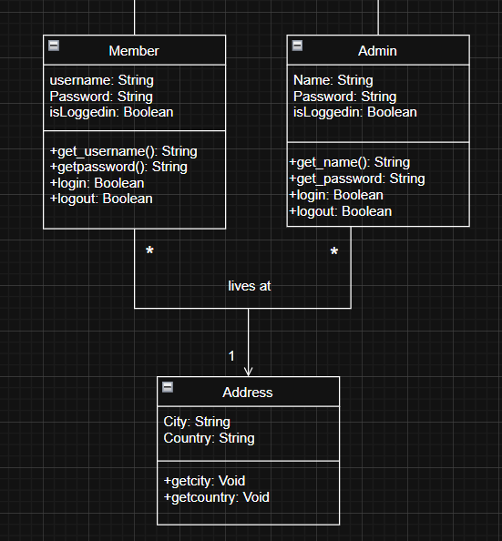

Description: Many users (Admin or Member) can live in one address (same country same city), but the difference is that the admin has higher privileges than a member, so we created an abstraction class (Address) and occurrences classes (Admin, Member) and connected them with a one-to-many association.

1. Delegation Pattern

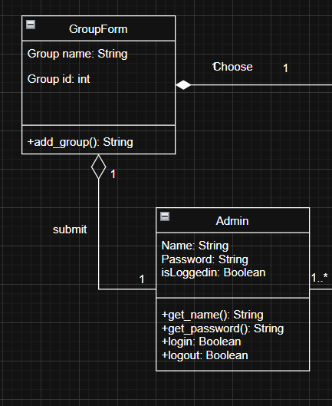

Description: The group name in the GroupForm class could be created using the existed get_name method from the Admin class, hence we used the Delegation pattern.

1. Singleton Pattern

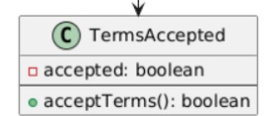

Description: No other class in all the class diagrams have the ability to create the instance (accepted) of the class TermsAccepted. Note the acceptTerms() is the getInstance().